How to Use a Dog Field Safely in Hot Weather
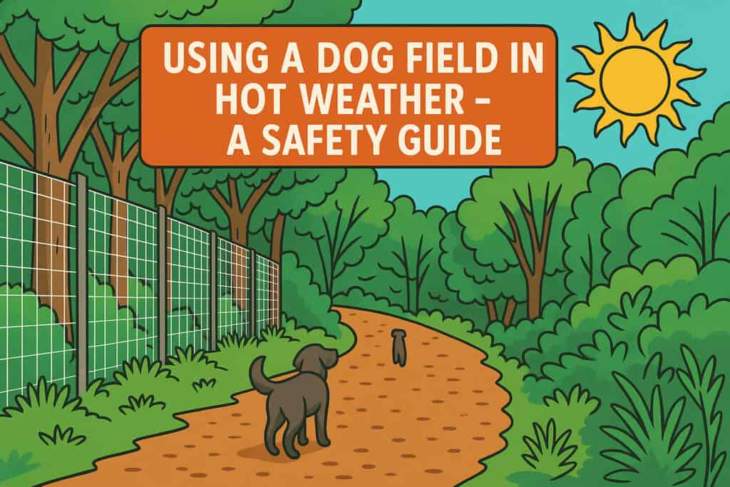

Hot weather can be glorious… for about five minutes, until you realise your dog is panting like they’ve just run the London marathon in a gorilla suit, and you’ve only just parked the car.
Dog fields are still very usable in warm weather (to a point), but there is an art to using them without accidentally melting your mutt.
So here’s a handy guide we encourage you to read. A few minutes of prep = a much happier (and safer) dog.

The Basics
Follow this chart – but use your noggin. We have a dog that has a double coat and is happy in -20°C – he brother is a sun worshiper. Know your dog.
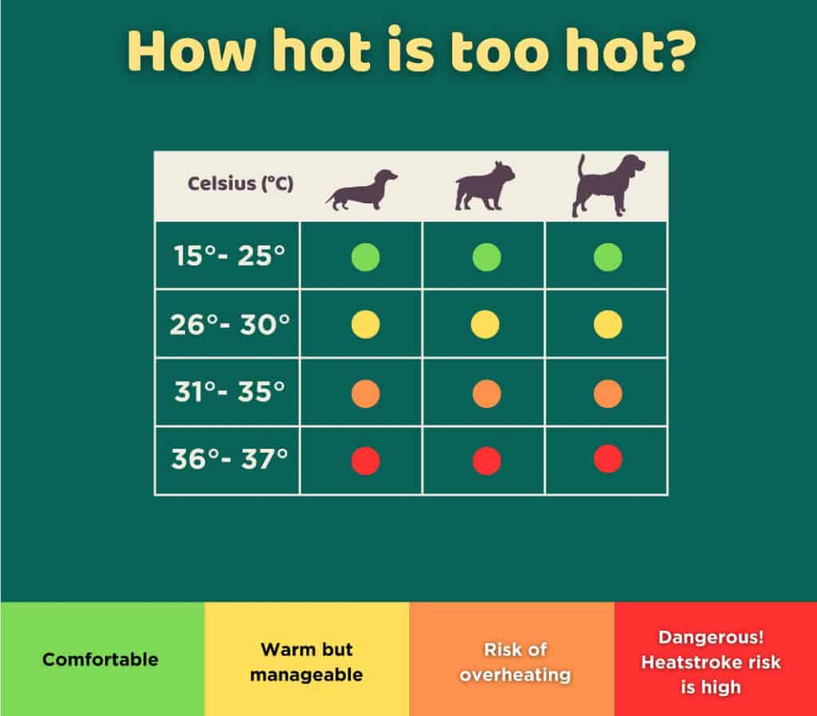

1. Choose Your Time Wisely (Yes, 2 PM is a Terrible Idea)
The hottest part of the day – roughly 11 AM to 4 PM – is basically a no-go zone for high-energy zoomies. If you’ve booked during this time, please consider rescheduling or downgrading to a chill sniff-and-wander session in the shade (on lead if necessary).
Pro tip: Early morning or evening bookings are epic. Think sunrise walks and golden-hour adventures. Many dog fields extend their normal hours during a heatwave but it’s worth asking your favourite field if they can open at dawn and dusk.

2. Do the Ground Test
Press the back of your hand against the ground for 7 seconds. Can’t hold it? Too hot for paws. Dogs can, and do get burns from hot surfaces – especially on artificial turf, tarmac planings (common dog field parking surface), and sun-soaked paths or structures (benches and platforms etc)
Hack: Bring along a cooling mat or towel for breaks, and stick to grass or shady patches.

3. Water: Not Optional, Non-Negotiable, Never Enough
Always bring water with you – even if you know the field has a supply because you never know when I pipe might have burst.
Bring more than you think you’ll need – for both you and the dog. A collapsible bowl and a few litres of water go a long way.
Bonus Tip: Run the tap for a while before you fill up the bowl – water standing in exposed pipes can get scorchio and if you let is run through a bit, you’ll get to the good stuff.

4. Know the Signs of Heatstroke (And Don’t Be That Person)
Heatstroke doesn’t just hit when dogs are obviously overheating. Early signs can be subtle:
- Excessive panting
- Bright red tongue or gums
- Disorientation or wobbliness
- Vomiting or diarrhea
If you see any of these – stop immediately. Get them into shade, pour cool (not cold) water over their body, and call your vet. Fast. The current guidance on this has changed recently – check it out here… What to do if your dog has suspected heat stroke.

5. Keep It Short and Sweet
Even if you’ve paid for a full hour, your dog might only need 15–20 minutes in the heat. That’s okay. It’s not a waste of money – it’s smart, safe dog ownership.

6. Shade Is Not Optional – It’s a Lifesaver
When booking a dog field, look for fields that offer shady areas (tree and, shelters). No shade? Maybe skip it that day.
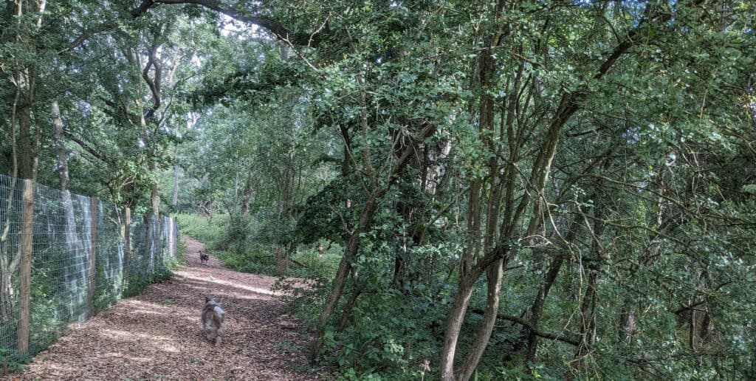Ettington Really Wild Walks – Pudding Furlong

7. Don’t Forget the Cool-Down
After the field, your dog’s internal engine might still be running hot. Avoid car journeys without AC, and don’t feed them a big meal straight away. Let them relax, cool down, and rehydrate.

💡 Bonus Tip: Check the Forecast Before You Book
We know it’s British weather and predicting it is basically a game of roulette – but still, checking the long-range forecast before you book can save you a sweaty dog, a wasted trip, and a whole lot of “should we just sit in the car with the AC on?”
Hot spells, sudden heatwaves, or even muggy days with no breeze can all make field visits less fun (and more risky). If it looks scorchio, it might be worth holding off or grabbing an early morning slot instead.
We all love a good blat about – but summer requires a bit more planning and a lot more awareness. If it’s too hot for you, it’s probably way too hot for your dog. Stay safe, stay cool!

